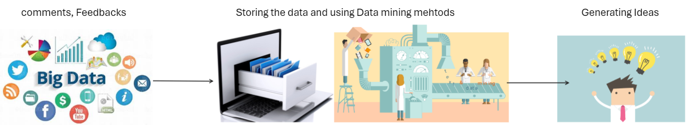

|  |  |
| --- | --- |
| A picture of a winding road and trees  TECHNICAL REPORT  Orange Jordan | A close-up of a logo  Description automatically generated  Overview  My project, 'Your Feedback, Our Future' is designed for Orange Jordan. The goal from this project is to explore the possibility of implementing a big data system using advanced data mining technology. This system transforms comments and feedbacks from multiple sources into insights and ideas, which helps in maintaining a continues improvement and innovation for Orange Jordan.  Student name: YOUSEF ABU ALI (21110294)  Instructor name: Rami Ibrahim |

1. Introduction:

* Big Data: the concept of big data has become more common in the current era. Big data is a name that represents the huge growth and complexity of the new data that is being generated around the world, ex. Data generated from social media platforms. As known, Big data has three main characteristics: volume, velocity, and variety. (Ellingwood, 2016)
* Big data, with it’s main characteristics demands very powerful technology and methods to help in it’s analysis. Moreover, managing these huge datasets requires good storage, advanced tools for analysis, and strong infrastructure.
* The Successful handling of these kind of data requires a smart approach by insuring the quality, security, and ethical practices for information.

The following are summarized examples of the applications of big data, which are also related to my idea, data generating system.

1. The global technology report of cisco:’

* As cisco’s report said business are currently prioritizing big data.
* The report discussed that 2/3 of the IT managers consider big data as a priority in the coming years.

1. Case study on Cisco Data Intelligence Platform (CDIP):

* The case discussed the current challenges of managing huge amounts of data, and it presented the CDIP as an example.
* CDIP is an important tool for the field of data mining.

1. An article the discusses the collaboration between Cisco and Cloudera:

* The collaboration between Cisco and Cloudera was meant to enhance the process of storing big data.
* It discussed the evolution of Hadoop tool and it introduced Apache Ozone.
* It mentioned the importance of using these tools as solutions for storing data.

1. An article that discussed the Evolution of data:

* It discussed the challenges faced by IT managers when trying to handle the huge amounts of data.
* It gave a suggestion for using hybrid solutions (ex. Cloud-based) approaches.
* It showed the importance of data mining methods to use in data generation.

1. An article the shows Cisco’s solution for Analytics and big data.:

* This article was overall mentioning the methods that Cisco addressed about the challenges of big data.
* It focused on scalability, data security, and cost.

The impact of big data in general:

* Big data is being used to understand customer behavior, improving health care process, as well as helping in reducing energy bills. (Yale Insights, 2016)
* Big data is also helping companies such as phone companies trach what people do throughout their day, such as their searches and purchases, which helps them in marketing. (Yale Insights, 2016)
* Big data is a great tool, which helps in understanding different aspects of life better, smarter, and more efficiently.
* Big data helps in understanding information and using them to make life better.

The application of big data technologies has proven its effectiveness across different sectors by improving the operational efficiency for these sectors. (Precisely, 2021)

* For example, in the healthcare sector it provides real time analysis which helps in building models that protects patient outcomes which optimize treatment plans and patients’ health.
* In finance big data has played an important role with fraud detection and risk management by providing real time analysis for Data and machine learning algorithms to boost security measures.
* In manufacturing big data has helped in improving production by minimizing downtime, reducing costs, and improving overall productivity.
* In retail big data has helped in analyzing and understanding customers’ behavior to provide personalized marketing and to enhance shopping experience and by that increasing satisfaction and revenue.

In the context of the company that I chose which is orange Jordan a telecommunications sector, the application of big data and such sector is a game changer. Using advanced data analytics orange can gain important insights by understanding customer behavior, preferences, and the overall performance of the network. This empowers orange to enhance its overall operational efficiency in various fields.

Problem statement:

* In this report, I aim to build a big data system for Orange through understanding their current practices in data management and feedback collection methods. My goal is to implement a system that uses data mining to gain valuable insights depending on customer behavior, suggestions, and complaints to produce ideas that would help in improving Orange’s products and services.

1. Research Study
   1. Research overview

Ethical components:

In The survey I conducted I made sure that people had the option to join or not, and their private information were kept private. The survey was designed to be clear, avoid harm, and easy for employees at orange to take part in. I made sure that it was fair and ethical research. The following are the ethical aspects of my survey:

1. Informed consent: I clearly stated that participation in my survey is voluntary, and I gave them the right to exit at any point of the survey. And I mentioned that their responses are only used for educational purposes.
2. Privacy: I assured the participants that no personal information is going to be collected and their identities are unknown. Therefore, I didn't collect any emails or names.
3. Security: I made sure that this survey is secure and protected against any unauthorized access, as I conducted the survey online using Google platform which is a secure platform.
4. Transparency: I made sure to clear the purpose of this survey for the participant, I clearly showed that it was for an educational purpose.
5. Avoiding harm: I made sure that the questions in my survey are designed to minimize any discomfort or feeling of harm for the participants, scratch there were no sensitive topics, it was clear and to the point.
6. Accessible: I gave the ability for any participant to access this survey.

Research methodology:

* + My survey questions included a mixed approach of both closed-ended and open-ended questions. It combined both quantitative and qualitative elements in order to gather insights from the employees in the IT department in Orange. As the closed-ended questions allowed for numerical analysis and the open-ended questions give the ability to obtain qualitative data, in order to ensure a good understanding of the IT department at Orange.
  + The survey was sent electronically to the IT department for the employees at Orange. I contacted a person within Orange organization who made sure to send the survey to the specified department.

Sampling technique:

* + The sampling technique I used was a Convenience sampling as the participant in the survey were chosen based on their availability and accessibility within the IT department who are related to the guy I contacted, as he distributed my survey to the IT department employees who are willing to participate.
  + The sample size for my survey was the number of employees in the IT department at orange, who received the survey and completed it, in my case there were 12 employees.

Survey Questions:

* General information: the questions related to gender and age was essential to understand some statistical data related to the participant profile.
* Awareness of big data: these questions were related to understanding the employee’s familiarity with big data concept and the personal trial and exposure to big data.
* The importance of big data: these questions such as the linear scale questions what were made to understand the importance of big data to the organization’s productivity.
* Collection of feedback: these questions where added to get a general understanding of the current available methods of collecting customer feedback, in order to help in identifying the current practices and preferences of the company.
* System evaluation: these questions were meant to understand the features that employees at the company would prefer in the system we're trying to make, such as the preferred access methods, and user friendly features. In addition to the key performance indicators regarding the generation system to provide insights into the employees expectation for the proposed idea.
* Special platform and sentiment analysis: these questions are meant to understand the participants perspective about implementing sentiment analysis. As well as getting information about the existence of a platform dedicated for obtaining customer feedback.
* Rating the idea and comments: at the end I added questions to understand the overall agreement of implementing a special platform made only for customer feedback. And I finished the survey by an open-ended and skilled question in order to gather insights about any concerns or suggestions, And the possibility that the employees would resist to adopt the big data system.

Questions directed to Orange management with answers:

1. What are the goals that Orange would want to achieve from the big data system proposed?

* We aim to understand customer needs and preferences.
* Understand our weaknesses and identify areas for improvements.
* We aim to predict customer churn and identify customers at risk.

1. What is the approximate budget for the proposed project, and is the budget flexible to possible changes during any phase of the project? (Najadat, Alsmadi and Shboul, 2012)

The following are roughly estimates for the budget of the proposed idea:

1. Cost for infrastructure:

* Hardware: Between 50,000 JD and 200,000 JD depending on the hardware scale.
* Cloud services: between 20,000 JD and 100,000 JD per year.

1. cost for software and tools

* Tools for big data analysis and data mining integration including license: between 30,000 JD and 100,000 JD.
* Data integration(combining data from multiple sources), and ETL tools(tools that help in organizing and preparing data for analysis): between 20,000 JD to 50,000 JD.

1. cost for development and integration

* Salary for development team: between 150,000 JD to 500,000 JD (depending on the size of The Team).
* Integration cost(which are expenses for combining and managing data, And external support and or consultants): between 30,000 JD to 100,000 JD.

1. costs for ensuring data security and customers privacy.

* Security infrastructure(encryption, access control, firewalls, etc) : it costs between 20,000 JD to 50,000 JD.
* Compliance and auditing (Ensuring company follow rules and regulations): around 10,000 JD to 30,000 JD.

1. cost for training employees

* Employee training costs around 10,000 JD to 30,000 JD.

1. Additional costs and emergencies

* Additional costs: 10,000 JD to 20,000 JD.
* For emergency: 50,000 JD's to 150,000 JD.

**Total rough estimate: around 410,000 JD to 1,350,000 JD**

1. Is there a specific timeline for the implementation of the proposed project, and is their a deadline that you would prefer?

A project like this might take around 8 months, however this is a roughly estimate and the duration might be adjusted based on the project requirements.

1. Could you suggest a specific scope for the project, including the features, functionalities, and integration with the systems that already exist in Orange?

* A platform for customers to submit feedback.
* Categorizing feedbacks.
* A platform for the organization to generate ideas.
* A system that employees can access the platform through.
* A dashboard that shows trends related to customers’ feedback.

1. What are the metrics that you would specify that would help in measuring the success of the project?

* Quality of Ideas Generated.
* Reduction in Customer Complaints or Negative Feedback.
* Impact on Business Metrics (e.g., revenue).
* Number of Successful Product or Service Improvements.

1. Do you have any suggested considerations that relates to security and privacy of data that we need to consider during the development and implementation phases?

* Consider implementing data encryption such as end to end encryption for customer data. It's important to secure the information between both sides during the transmission and storage.
* Provide the customers with an option to submit their feedback anonymously. This would help in respecting customer privacy preferences as well as encourage more people to share their feedback, be honest, and open.
* Security audits as well as regular assessment for the vulnerability on the system.
* It's important to comply with data protection regulations such as CPA and GDPR. This is important to avoid any legal problems, fines, and most importantly reputational damage.

The survey Link: <https://docs.google.com/forms/d/e/1FAIpQLSfrDS2pqHqSBJ0a2Xvl_FKDPzEuBfPhYb2RDfJ1I3XkAuo90A/viewform?usp=sf_link>

* 1. Analysis:
* Q1:

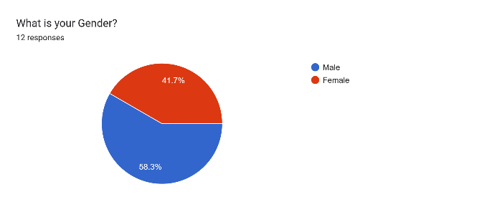

This pie chart shows that 58.3% of the employees that answered this survey where identified as male, and 41.7% were identified as females.

* Q2

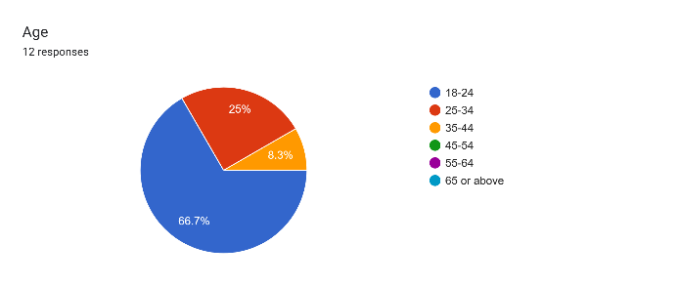

This pie chart shows that 75% of orange IT team that answered the survey where young, with an age between (18-44)

* Q3

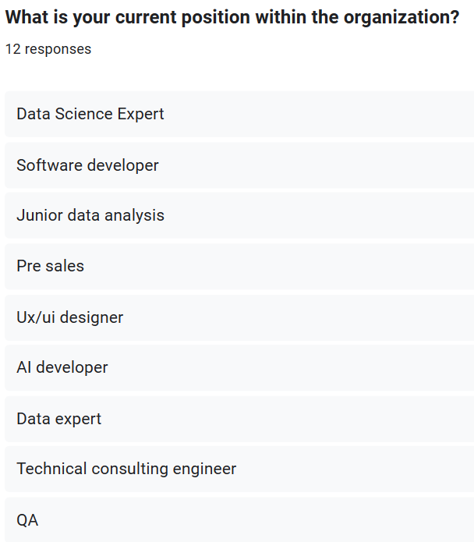

From the responses of this question, I figured that orange IT team has a wide range of experts, with positions such as data science expert, software developer, junior data analysis, pre sales, designers, AI developers, data experts, etc.

* Q4

This pie chart shows that 41.7% of the employees has good knowledge of big data, 25% have some knowledge, and 33.3% are new to it. I think that training employees could help in having better knowledge of big data considering that it's very important.

Forms response chart. Question title: How familiar are you with the concept of big data?
. Number of responses: 12 responses.

* Q5

This pie chart shows that 91.7% off the employees have encountered or used big data, which suggests that people have good awareness or a little bit of knowledge on big data.

Forms response chart. Question title: Have you encountered or used big data technologies in your personal or professional life?
. Number of responses: 12 responses.

* Q6

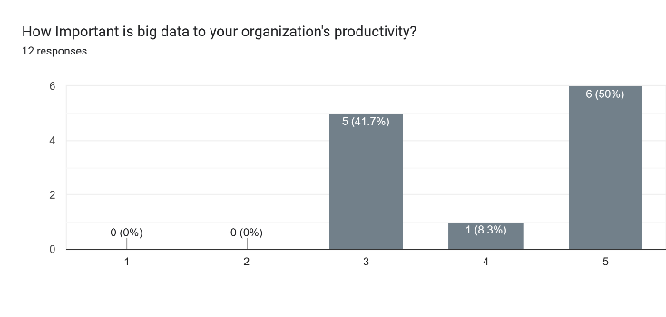

This chart shows that most of the employees believe that big data is important for their productivity and 41.7% are neutral.

* Q7

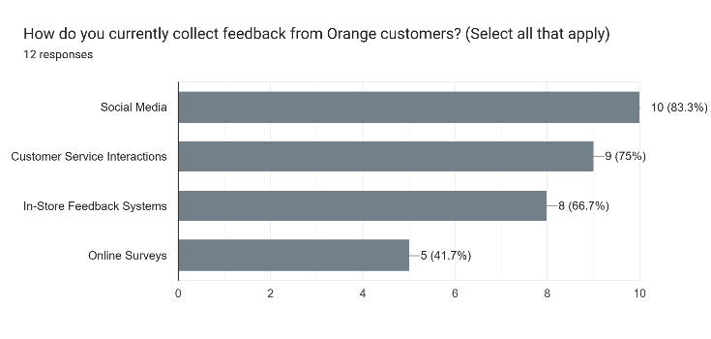

This bar chart shows the collection methods of customer feedback. With social media being the top feedback collecting method followed by customer service interaction, in store feedback and online surveys. Therefore we should focus more on social media

* Q8

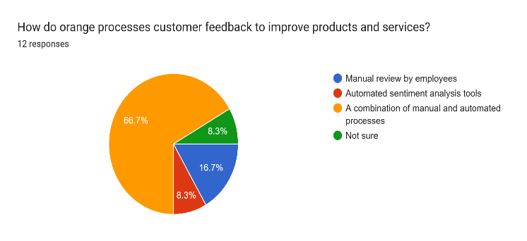

This question was meant to understand the current customer feedback processing method and most of the employees who conducted the survey said that it's a combination of manual and automated process. Which means there would be a good understanding of the system suggested.

* Q9

Forms response chart. Question title: When it comes to gathering customer feedback, which types of feedback do you think are most valuable for generating innovative ideas? (Select all that apply)
. Number of responses: 12 responses.

This question was meant to understand the most valuable type of feedback that would help in generating good ideas, and it showed that negative feedbacks are the most important ones.

* Q10

Forms response chart. Question title: What features would you consider important for a user-friendly interface for employees to engage with the proposed idea "generation system"?
. Number of responses: 12 responses.

This question was meant to understand the features that the employees of orange would prefer to have in the system the most agreed on feature was visual representation of Data insights followed by the other three features in a similar percentage.

* Q11  
  Forms response chart. Question title: In terms of accessing the idea generation system, which method would you prefer? (Select one)
  . Number of responses: 12 responses.

This question was meant to address the preferred method among the employees to access the system, and the pie chart showed that both software application and mobile application or similarly preferred.

* Q12

The bar charts for this question showed that the quality of ideas and reduction and customer complaint and negative feedback are the most important performance indicators for the success of this system. Followed by the impact on business metrics, add number of successful products.

Forms response chart. Question title: What key performance indicators do you suggest for evaluating the effectiveness of the text generation system over time? (Select all that apply)
. Number of responses: 12 responses.

* Q14

Forms response chart. Question title: Does Orange Jordan currently have any systems or platforms that you believe could be seamlessly integrated with the proposed idea generation system to enhance its effectiveness? (Select one)
. Number of responses: 12 responses.

This pie chart shows that most employees has agreed on the availability of a system that could be integrated with the generation system which would help in better results.

* Q15

This pie chart shows that most employees had agreed on incorporating sentiment analysis into the system which would help in understanding customer feedback better and provide better results.

Forms response chart. Question title: Do you believe incorporating sentiment analysis (Positive, Negative, Neutral) into the system, to understand the emotional tone of customer feedback, would be beneficial? (Select one)
. Number of responses: 12 responses.

* Q16

Forms response chart. Question title: Does Orange Jordan currently have a dedicated platform where customers can write comments and share their feedback?
. Number of responses: 12 responses.

This pie chart shows that most employees has agreed on the availability of a platform where customers can share their ideas, we could use this platform in the generating system.

* Q17

Forms response chart. Question title: On a scale of 1 to 10, how do you rate the idea of implementing a dedicated platform for customers to write comments and share feedback?
. Number of responses: 12 responses.

This bar chart shows that most employees we're happy with the idea of implementing a platform specifically need for customers to share all their ideas, comments, and feedbacks. Which would help and building a better generating system.

* Q18

Forms response chart. Question title: What concerns, if any, do you have about adopting big data technology in your workplace? (Select all that apply)
. Number of responses: 12 responses.

This question was meant to understand the concerns of the employees related to the system. Most employees are concerned about security which means we have to put that into consideration. The second concern was the lack of understanding of this system which means that we have to train the employees. The third concern was the integration challenge, which indicates that we would need professional people to add the system to the everyday workflow. The third concern was there is assistance from employees which indicates that we would have to give a course showing employees the importance of applying a big data system. And the last concern was cost, which indicates that we would have to use the help of some investors during the development of our system.

* Q19

Forms response chart. Question title: On a scale of 1 to 10, with 1 being not at all resistant and 10 being very resistant, how resistant do you think employees in Orange might be to adopting big data technology?
. Number of responses: 12 responses.

This bar chart shows that there might be some resistance from the employees at orange when adopting big data technology, which means that we would have to convince the employees about the importance of employing big data technology, and how it would affect their workflow effectively.

* Q20

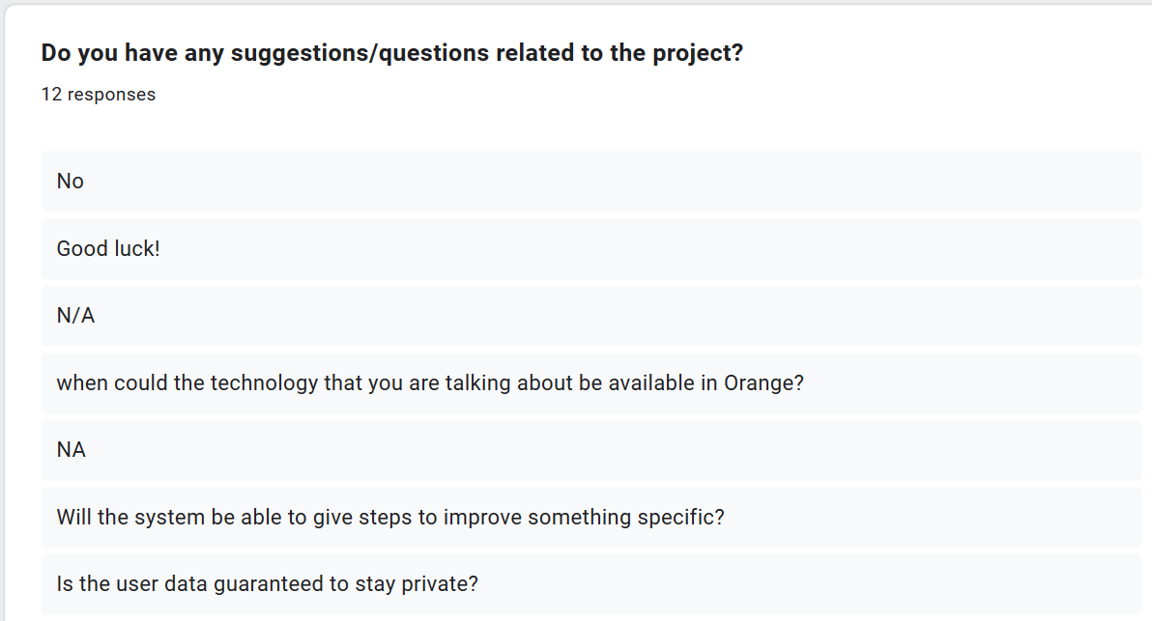

This question was meant to benefit from suggestions or questions from the employees. The 4th answer showed that this employee is excited about the system. The 6th question gives me an idea to add steps on how to improve certain things provided by the system. And the last question was showing concern about customers privacy and security.

* Conclusion:

This survey has showed a variety of IT experts, which would help us when developing the proposed system. It also showed a good familiarity with big data, which would make it simpler to teach the employees about the big data system. It also showed that the organization uses a lot of feedback collection methods with a platform that helps them understand customer’s feedback. Moreover, this survey gave me an idea of what to focus on when gathering customers feedback as well as focusing on the features that will be added to the big data system. In addition to understanding the methods that employees would prefer when accessing the system. At the end it showed me that employees are most willingly to adopt the big data system and that they are excited about it. However, I think that when training for the employees is done, they would be more excited about it and more willing to adopt this big data system.

* 1. Accuracy:

I performed my survey using Google forms. It was a very great tool that was easy to use and to understand, and it provided good analysis and illustrations for the responses. My sample was the IT department at Orange company. And I think that it was a very good sample because most people who would understand the importance of such system are the employees that understands technology.

I reached these employees from a family member that used to work in orange, so I consider it as a (convenience sampling). However, I think it was a good sampling method because it made me reach the target I wanted at Orange.

Considering the survey questions, I used a mix of qualitative and quantitative research Methodology. With a mix of open-ended and closed-ended questions. The quantitative questions made me understand employee’s knowledge of big data as well as their resistance to the system suggested. On the other hand, the qualitative questions made me understand the properties of the system that the employees would prefer, as well as the concerns, and suggestions from the employees. The closed-ended questions made me focus on specific things related to the system such as features, as well as some concerns from the employees such as security. However, the open-ended questions made me understand the roles of the employees that answered the survey as well as questions or suggestions for improvements.

I think that the survey was reliable because I chose the most important people from orange company that would help me understand the possibility of implementing the suggested big data system. And I think that the responses and the analysis of the survey were accurate to some level because some questions we're a bit close to each other, but they didn't give the same expected answer. such as the question whether the employees are familiar with big data, and the question of whether they have encountered or used big data before. I think that the answers were a bit inaccurate, as in the first question they said that not all of the employees where very familiar with the big data concept, and in the second question most of them said that they have used big data system which doesn't make much sense.

One of the problems that I encountered during my research is that the employees took a lot of time to answer the survey. So, I think if I had to do it all over again, I would visit orange campus and perform interview questions with at least 10 employees in order to get faster responses, more reliable, and to get more suggestions and questions that would help me improve the big data system, as well as to understand the functionalities at orange better to develop a better big data system.

Overall, the survey was reliable, and I wrote the questions as simple as possible for everyone to understand easily. And based on the results I think that the big data system could be adopted in Orange. However, I think that the employees need to have some training sessions to help them understand the importance of big data better.

1. **Project management Plan:**
   1. **Solution:**

Based on the survey I conducted I concluded that the responses were very supporting for my idea, and it could be a turning point for the functionalities at Orange.

And therefore, I am proposing my project which is implementing a big data system using advanced data mining technology. The system main functionality (goal) is to transform client’s comments and feedbacks that are gathered from multiple sources, into beneficial insights and ideas that would help in maintaining a continuous improvement and innovation for the products and services at orange Jordan.

I had a phone call with an employee that works in the IT department in orange, and he told me that they take the comments and feedback from people very seriously and they use them to provide better products and services. However, he told me that they do this in a manual way, by reading each comment manually. And he told me that their vision is to make all their clients satisfied and loyal. Therefore, the system I'm proposing is going to help them reach their objectives and aims, and at the same time reduce the amount of human effort and time to achieve this goal.

* 1. **Project Aims and Objectives**

The proposed big data system it's very important for orange Jordan for several reasons:

1. Understanding customer preferences, concerns, and feelings about their products and services.
2. The ability to transform customer comments into real-time ideas, which would help the organization to improve their products and services continuously.
3. Improving the productivity and efficiency of the company by providing real-time analysis of customers’ feedback and reducing time and effort.
4. Providing a competitive advantage against other companies by putting orange Jordan at the front of the technological innovation in the telecommunication industry.
5. Enhancing customer satisfaction and loyalty by continuously listening to their feedback and implementing improvements, which would make the customers loyal, satisfied, and recommend the company to other people.

Aligned with the smart goals criteria, the big data system I'm proposing achieves specific, miserable, achievable, relevant, and timely:

Specific:

* The big data system I proposed aims to enhance the customer feedback process specifically at Orange through implementing advanced data mining methods. It aims to understand customer sentiments, leading to important insights that the company could turn to actions.

Measurable:

* The success of the system I proposed is going to be measured through key performance indicators that will show its efficiency in generating ideas, and the improvement in customer satisfaction.

Achievable:

* The goals of the project I'm attempting are very realistic and could be achieved in a specific time frame.

Relevant:

* The project I'm proposing is very relevant to orange objectives. It helps with innovation, customer satisfaction, and improves the competition within the telecommunication industry.

Timely:

* The project has a clearly defined timeline for implementation, ensuring that all the milestones are achieved in a specific time.
  1. **Project Management Plan**

This part is an introduction for the limited project management plan, this section give some key aspects about the project, which includes the costs estimation, scope of the project, timeline, metrics for measuring quality, strategies for communication, risk approaches, and the resources related to the proposed big data system at Orange Jordan.

1. Cost: I estimated the cost for this project as 1,350,000 JD, including the expenses that are related to software, hardware, and human resources. This estimation was derived from a project requirement and market analysis broken down to estimations.
2. Scope: the goal of this project is to deliver a complete big data system that include features such as easy to use interface, including sentiment analysis, and a platform for customer comments and feedbacks.
3. Time: I actually estimated that the project is going to take around 7 months, including additional time to keep in mind any challenges and adjustment during the development, testing, and the implementation.
4. Quality: the quality metrics are going to be measured through the effectiveness of the system, user satisfaction, reduction in compliance, and the overall accuracy of the sentiment analysis results.
5. Communication: I will assure effective communication through having regular meetings with The Team, regular progress reports progress, and using collaborative platform to make sure for daily communication between the team members and the stakeholders.
6. Risk: to handle all the possible risks that we could encounter, we are going to look out for any problems that might happen at any phase, act quickly as a team to solve them, and we will have backup plans ready for any pitfalls during the development, testing, as well as the implementation.
7. Resources: the project will involve advanced hardware, software tools, as well as experienced human resources, in order to ensure a successful development and implementation of the proposed system.
   1. WBS, Gantt Chart, and Milestones:

The Guntt chart is attached as a .gantt file, however this is a picture of the guntt chart:

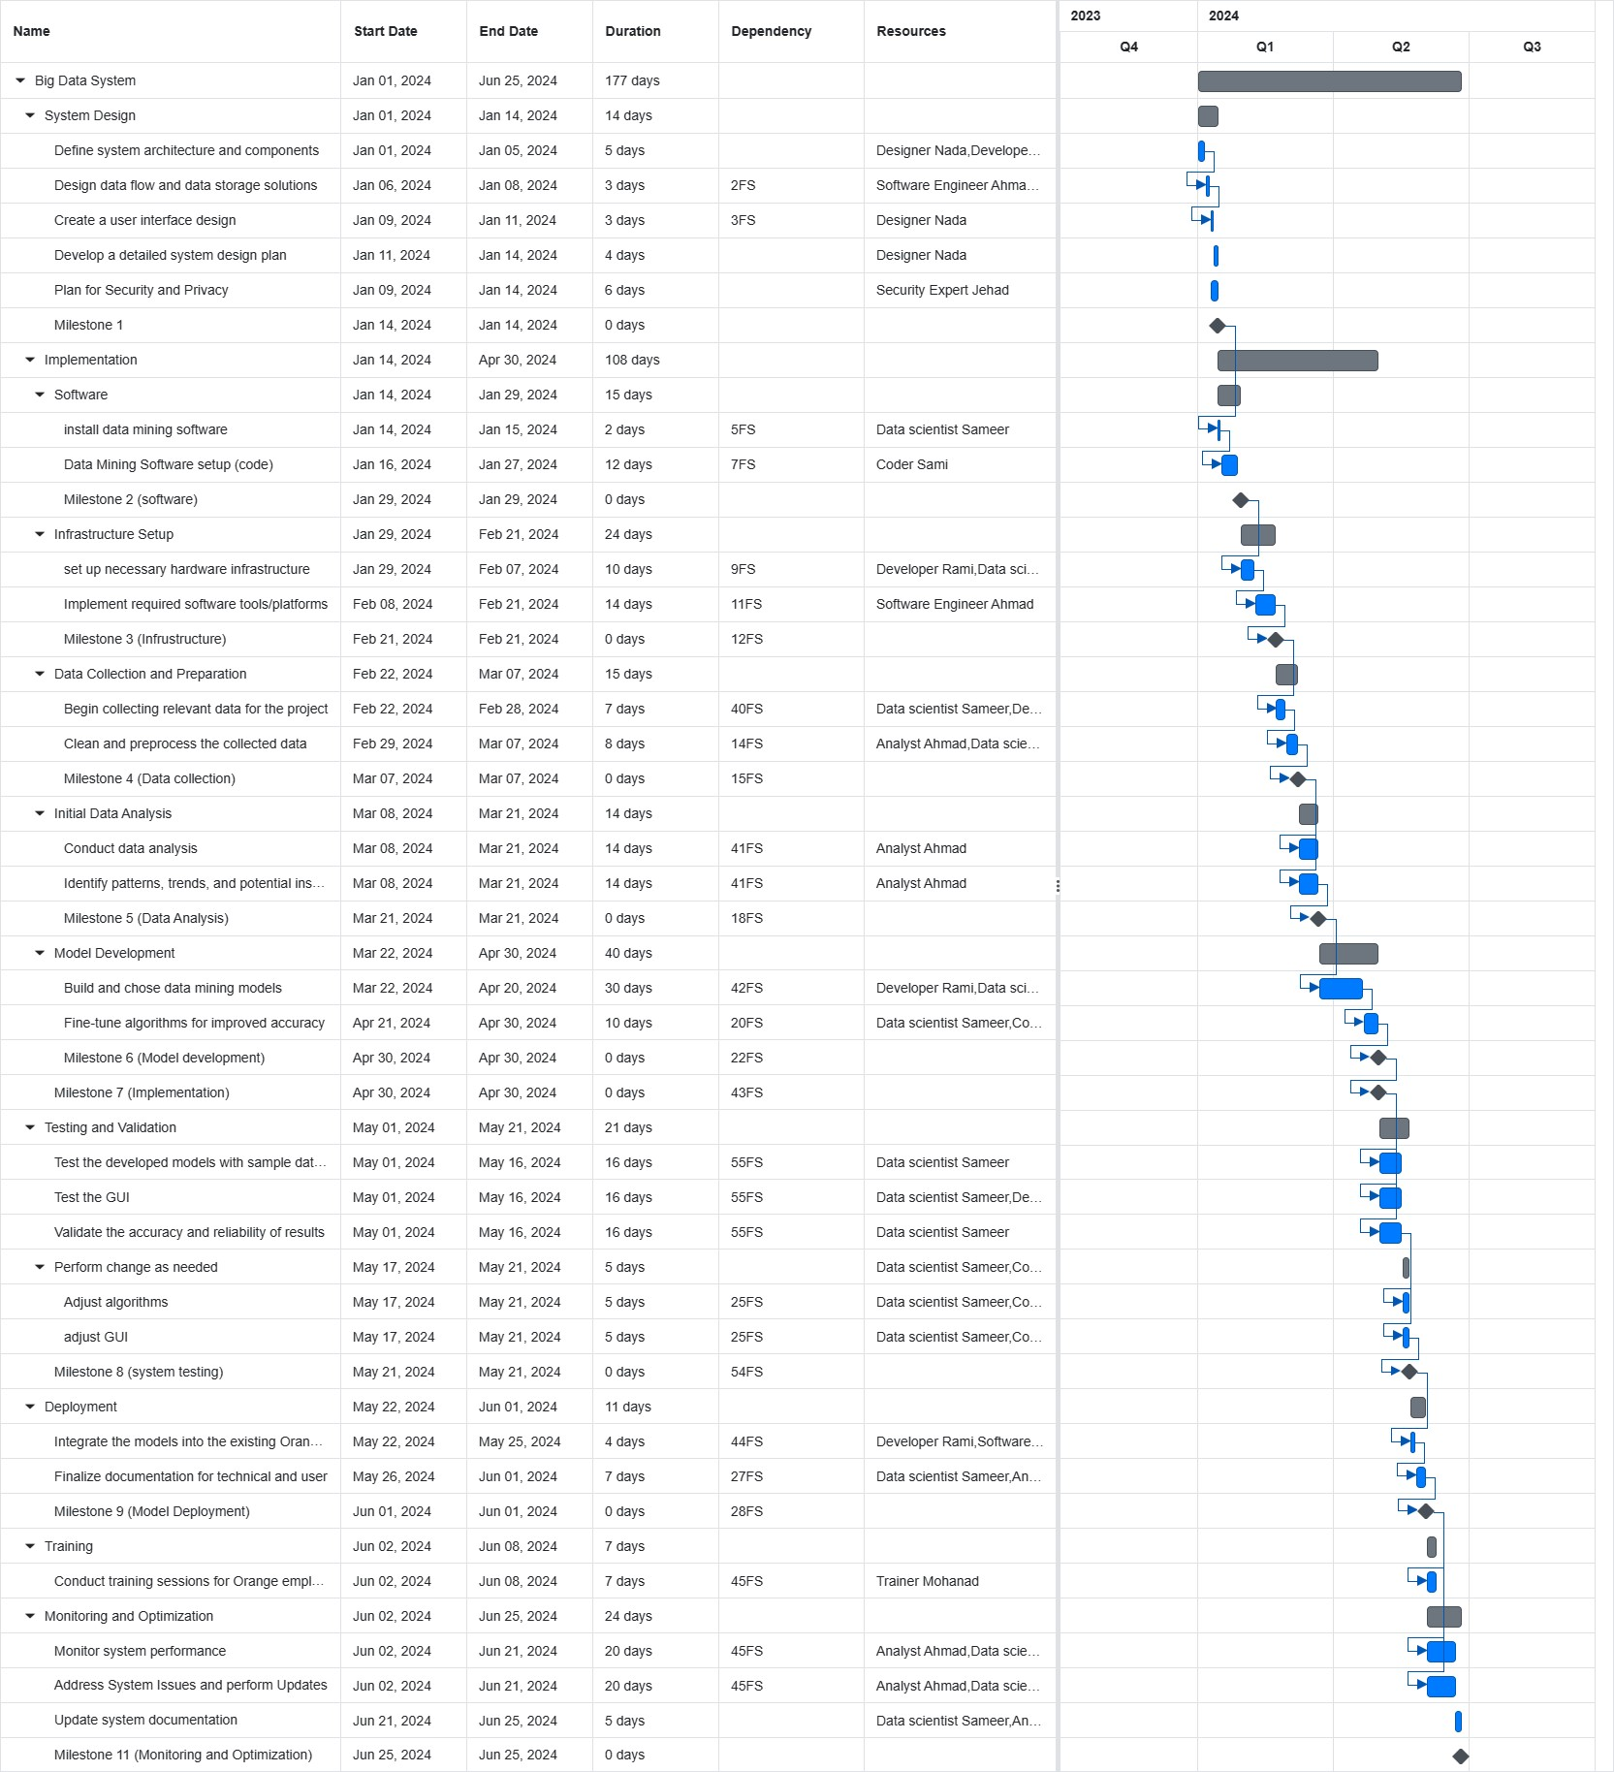

* 1. The Comprehensive project management plan:
     1. Describing the milestones:
* Milestone 1( System Design):

At this milestone we make sure that we have our big data system, and to make sure that security plan is done.

* Milestone 2 (software):

This milestone is important to make sure that the data mining software are installed.

* Milestone 3 (infrastructure):

This milestone is to make sure that all the necessary hardware for the project and the required software tools are available. Making sure that the project technical foundation is ready.

* Milestone 4 (collection of data):

This milestone makes sure that we have collected the data we needed for the project in order to use it as an initial phase (sample), and this is the first step in implementing the big data system which aims to generate insights from the data.

* Milestone 5 (data analysis):

This milestone is to make sure that we conducted primary data analysis using the selected data and the data mining techniques, this milestone is considered as the first step in extracting meaningful information from the data collected.

* Milestone 6 (model development):

This milestone helps in making sure that the data mining models have been built, including tuning the algorithms for better accuracy. This milestone is critical to ensure that the core capabilities of the system are working.

* Milestone 7 (implementation):

At this milestone we make sure that we have done all the steps for the implementing the model starting from the software, to the infrastructure setup, to data collection and preparation, to data analysis, and ending with model development.

* Milestone 8(System testing):

In this milestone we make sure that the testing for the models are done, and by that we make sure that our model(system) is reliable and accurate.

* Milestone 9 (Model Deployment):

This milestone is to ensure that the big data system has been integrated with Orange system, indicating the preparation of the system.

* Milestone 9 (training):

In this milestone we make sure that training has been conducted for the employees at orange, and that the system is being applied gradually. By that we make sure a smooth transition to the new system with the trained employees.

* Milestone 10 (Training, monitoring and optimization):

In this milestone we make sure that training has been conducted for the employees at orange, and that the system is being applied gradually. By that we make sure a smooth transition to the new system with the trained employees. Moreover, we make sure that we have monitored the system performance through a period of time, showing the ongoing optimization and improvement for the system.

Project scope description:

1. System design and security: provide a good design for the system both the organization’s system and the customer platform. As well as provide a plan for security and privacy.
2. Data mining implementation: installing data mining software and preparing it.
3. Infrastructure setup: providing and setting up all the necessary hardware infrastructure, and implement that required software tools and platforms.
4. Data preparation: collect the necessary data for the project, that includes cleaning and preprocessing the data.
5. Data analysis: conduct a primary data analysis using the data mining techniques that were selected. As well as identifying trends and patterns (insights) in the data.
6. Model development: that includes building and preparing the data mining models, as well as fine tuning the algorithms during the process to improve the accuracy of the results.
7. Testing the models: test the models that were developed with samples from datasets related to the organization. As well as validating the accuracy and the reliability of the outcomes.
8. Model deployment: integrate the data mining models into the existing orange system. As well as finalizing the documentation for technical and user manual.
9. Training: conduct training for the employees at orange to understand the system and how to deal with it.
10. Monitoring and optimizing: monitor the performance of the system and optimize the algorithms if needed. As well as performing a final documentation.
    * 1. WBS dictionary:

The WBS dictionary is a document that provides detail about each element in the WBS. It helps in ensuring clarity and understanding throughout the project life cycle. It provides in-depth explanation for each element in the WBS, which helps in breaking down the complex tasks into simple understandable components. Moreover, it clears the definition of the scope by providing details about each work, ensuring good understanding of the scope, which helps in preventing errors and keep the project focused on the main objectives.

* + 1. Budget Assumption

In the budget assumption table, I have mapped out the financial aspects of the big data project at orange. It includes building a secure system, obtaining the data, analyzing it, and employing it. I have accounted the salaries, hardware, software, training, and added 20% of the total budget just in case. By that, everyone knows where the money is being spent on.

* + 1. Stakeholder:

1. Internal stakeholders:

* management: leaders and decision makers in the organizations have an important impact on the overall project. They set the overall goal and vision of this project, choose resources, and make decisions. Management support is very important to secure the necessary resources and to ensure alignment with the organization’s goals.
* Employees: the project team(staff members) our internal stakeholders which are involved in all the project phases. Ensuring the employees’ commitment, using their skills, and their cooperation is very important for achieving the project milestones. Engaging the employees in the project and addressing their concerns and ideas well enhance productivity and the overall success of the project.
* Shareholders: the shareholders represent the ownership in the company such as the CEO in our case, it's very important to have clear communication with the shareholders and to be as transparent as possible with them in order to help with their expectations.

1. External stakeholders:

* Suppliers: the suppliers are the stakeholders that provide resources, materials, or even services that are necessary for project implementation. Good time delivery, quality, and low cost of these inputs will impact the project timeline and outcome.
* Customers: the end users such as the employees in the company or even orange customers who are using the system to write feedback are considered important external stakeholders. Their satisfaction is a perfect direct measure for the project success. Having regular feedback, and meeting their expectations are very important for project acceptance.

1. Main impacts:

* support and resources: the stakeholders’ support is very important to secure both resources human and financial that are crucial for the project.
* Risk management: understanding and clearly identifying the stakeholders’ concerns is important for effective risk management, and reducing potential problems during project execution.
* Alignment of project with the goals: it's important to align your project with the goals of both the internal and external stakeholders to ensure long-term success.
* Communication: it's important to have regular and transparent communication with the stakeholders, in order to build trust and help in managing their expectation through the project life cycle.
  + 1. Critical Path Analysis:

The critical path is the longest sequence of important tasks that must be completed on time in order for the entire project to be finished on the time specified. Any delays in any of the tasks in the critical path will directly impact the project timeline, while delays in the non-critical tasks will not affect the final end date.

In our case the critical path involves the following:

* system design(January 1-January 14): this is the starting point of the project and it shows the minimum project duration.
* Implementation(January 14-April 30): this includes the software development, infrastructure setup, collection of Data, data analysis. Delays in any of these subtasks might affect the schedule.
* Testing and validation(May 1-May 21): any work on the issues that exceeds the time limit when impact the project (project delay).
* Model deployment(May 22-June 1): this involves integrating the model into orange existing system. Any issues during this phase may lead to exceeding the time limit and delaying the project.
* Training (June 2-June 8): this involves training all the employees on the new system. And it should be done during the time specified and it wouldn't affect the monitoring and maintenance, however, it could be considered part of the monitoring and maintenance.
* Monitoring and maintenance (June 2-June 25): this phase involves monitoring and maintaining the system for the last time including documentation, this is the last part of the project and it should be done during the time specified to make sure that everything works perfectly in order to close the project.

* + 1. Risk management plan:

A risk management plan is considered as a structured approach that we use to identify, access, prioritize, and mitigate the risks in a project. The main goal of using a risk management plan is to clearly identify any issues that would impact the achieving of the goals and objectives.

We start by thinking all of the possible scenarios that could happen during the implementation of a project, and addressing a plan for it, such as avoidance, transference, mitigation, or acceptance. Then based on these scenarios(risks) we find the probability and impact matrix for each one, in order to know what risks we should be ready for the most and how. And by that we save time and money, protect sensitive data, and boost the success of the project.

* + 1. Change management plan:

1. Change management challenges:

* Resistance from employees: there's a possibility that the employee could resist adopting the new technology due to their fear of job insecurity, unfamiliarity with the new technology, or even having concerns about changing their routine.
* skill issues: introducing a new system such as the big data system could require new skills. Therefore, the employees will need training, and we might need to hire an external expert to help us train the employees.
* bad communication: poor communication related to the reasons for the change, the benefits, and the steps related to it could lead to confusion among the employees and resistance to the new system.

1. Change management plan: big data system at Orange:
2. Planning phase:

* identify the internal and external stakeholders.
* Define the level of influence and the interest for each stakeholder.
* Evaluate how the new big data system is going to impact the current processes, controls, and the responsibility for each employee.
* Identify the challenges and the areas that require big attention.

1. awareness phase

* Clarify and simplify the main goals and benefits of this big data project.
* Use different communication methods, such as meetings, and emails to clarify the goals and benefits.
* Gave the employees the ability to express their concerns and to ask questions.
* Provide answers that are honest and transparent in order to build trust.

1. readiness phase

* Performed training programs for their employees.
* Provide accessibility to multiple learning resources, such as online courses or workshops.

1. resilience phase

* Provide frequently asked questions, and programs to mentor the employees for daily support.
* Show employees the availability of support resources at all times

1. measurement and adoption

* set key performance indicators for user adoption rate, efficiency of the implemented system, and employee satisfaction.
* Use feedback methods and performance metrics two improve the big data system daily.
  + 1. Quality management:

Quality management is important for the success of any project, it helps in ensuring that the deliverables are met or exceed the wanted standards for the best, as well as the stakeholder expectation. The following are the quality management processes I applied to my big data project at orange:

1. Quality planning:

* quality goals were defined, by focusing on user engagement, adoption of the system, and technical perfection.
* Ironed identified metrics such as the user engagement rates, and percentage of user adoption, as well as the technical issues, were identified to ensure best quality.

1. Quality assurance:

* Strong processes for testing were adopted to identify any technical issues and errors in the big data system.
* Validating each feature in order to ensure its quality as well as its alignment with the project requirements.

1. Quality control:

* Continuously monitoring the user engagement and the technical performance to identify and solve any potential issues.

1. User engagement and adoption:

* Having daily assessment for the user engagement and adoption rate which would provide insights into the effectiveness of the system and user acceptance.

1. communicating with stakeholders:

* Having regular communication with stakeholders in order to gain feedback on the quality and expectations.
  1. Critical Evaluation of the Project Management Process

The project management plan it's considered as the guidebook of any project, it helps everyone to stay on track with their requirements as we develop the big data system for orange Jordan. At this part I am going to look back at what I have done, why I did it, and how I could have made things better. This review will make a quick check-up in order to see what worked well, and what improvements for future projects.

1. Critical evaluation for the project charter:
2. Project objectives

* What have I done:
* At this part I outlined the objectives that are related to customer feedback, efficiency of this system, competitive advantage, and most importantly the customer satisfaction.
* why I have done it:
* I have defined these objectives in order to use it as a road map for my project, as it guides my project towards achieving the goals wanted and have the best outcomes possible.
* what could have I done better:
* I could have add more details related to certain objectives, for example instead of saying I want to increase customer satisfaction, I could have said that I expect to increase the number of customers by 85% for example, by increasing the customer satisfaction, relying on making more advertisement related to my project using social media to reach all The Wanted clients.

1. Deliverables

* What have I done:
* At this point I have clearly stated what are the expected deliverables from this project, such as the big data platform, the user interface, the application, Andy models.
* why I have done it:
* Clearly identifying the deliverables for this project gives everyone an expectation for what should be done and provides a good base for evaluating the success of the project.
* what could have I done better:
* I think that in this part I could have added very specific technical features or even functionalities for each one of the deliverables in order to provide a more detailed scope.

1. business case

* What have I done:
* On this part I explained the business case, focusing on customer satisfaction, increasing revenue, and increasing efficiency for the operations of the business.
* why I have done it:
* This part is important in order to demonstrate that this project aligns with the goals at the organization I'm working with, and the potential benefits that comes out of it.
* what could have I done better:
* I think that in this part I could have added specific statistics related for my survey in order to show the employees agreement of this project in order to show the importance of this project.

1. scope and exclusion

* What have I done:
* At this point I clearly identified the things that are included in the scope, and the things that are excluded from the scope regarding my project.
* Why I have done it:
* I have done this in order to set specific boundaries to prevent any Conflicts during or after the project, as well as to manage the stakeholder’s expectation.
* What could have I done better:
* I could have written more details for each item either in-scope or out-of-scope, in order to enhance the understanding, as well as prevent misleading anyone.

1. The project team and stakeholders:

* What have I done:
* In order to identify all the project team members, including the roles and the other stakeholders such as the CEO, external consultant, and security expert.
* why I have done it:
* In order to clearly show the individuals that are important for the project of the success, and to increase the understanding of what should be done.
* what could have I done better:
* At this point I could have specified the role that each stakeholder is going to take at this project, by adding more details to clarify their contribution.

1. Critically evaluation for the project scope:
2. Project objectives and project deliverables are the same as the critical evaluation for the project charter.
3. project milestones

* what was done:

I have outlined 10 project milestones, that include the system design and security, software, setting up infrastructure, collecting data, data analysis, model development, implementing phase(ending of the most important phase), testing phase, model deployment, end training.

* why I did it:

in order to provide a specific timeline for the project progress and completion, and to ensure that no farther step begins before the previous one ends, in order to ensure having successful deliverables. As well as to ensure that the project is done at the specified time

1. project technical requirement:

* what was done:

at this part I listed the functionalities for other systems included in this project, including the system for employees (program), and the customer feedback application.

* why I did it:

in order to define the technical requirements for each system, to ensure having a clear understanding of what are the functionalities and the capabilities of each system.

* what could I have done better:

at this point I could have added details about the specific technologies or the algorithms that are going to be used in this project to enhance clarity.

1. Evaluation for the stakeholder engagement matrix:

I chose for stakeholders for the stakeholder matrix that have different roles in this project:

1. CEO:

For the CEO I gave him a medium level of interest, as the CEO cares about the successful projects that happens in his company, however he wouldn't be too much engaged in it. And I gave him a high level of influence because he is the head of the company and any decision or action that he takes could strongly influence this project.

1. IT team:

For the IT team that includes any employee such as data analyst or data scientist. I gave them a high level of interest, as they are the most stakeholders engaged in working on this project. I gave them an influence level of medium because they have good control over the outcome of the project, as if these stakeholders didn't work hard for the project, it will influence the project outcome badly.

1. System Administrator (Fadi)

The system administration keep an eye on the IT team while they're working in order to make sure that everything is working perfectly, and the system is working as it's supposed to be. Therefore I gave him a level of interest between medium and high because he should be engaged with the IT team on what they're doing but he wouldn't be working on it. Also I gave him a level of influence between medium and high as if the System Administrator didn't keep track on what is being done the project will be at danger.

1. Suppliers

I gave the suppliers a low level of interest as they wouldn't be engaged in working on the project, however they have a level of influence medium as they are a crucial part when providing all the material we need.

1. Evaluation for risk management plan:

In the risk management plan, I included scenarios for the risks that could happen during the phases of the project. I also gave a mitigation plan for each one of them. And then I sorted each one of them in the probability and impact matrix. And I will discuss each one of them.

1. The first scenario is hardware or software failure. the mitigation plan for this scenario is avoidance, as we should avoid having hardware or software failure by taking the proper precautions. And the probability impact matrix I sorted this scenario as medium probability as it doesn't happen frequently, although it could happen from a human error, or even natural causes. And I gave it a medium impact on the project, as it might affect some certain aspects of the project, but we could find a substitute for it.
2. The second scenario is bugs or errors in the system that would lead to data security breach. The mitigation plan for this scenario is transparence, as we could give this responsibility for a stakeholder that could manage the security of this system by using precautions such as encryption. I sorted this scenario in the matrix as low probability because it happens rarely. and I gave it a high impact, as it could affect the leak of important, sensitive data. Which would impact the project and the company badly.
3. The third scenario is and natural disaster or power loss. the mitigation plan for this scenario is avoidance, as we could use methods to store data in a cloud for example or use a system that generates power if we had power loss. I sorted this scenario in the matrix as low probability Because losing power or natural disaster doesn't happen frequently. And I gave it medium impact because it's a temporary thing, but it could affect some aspects of the project such as hardware damage, or data loss.
4. The fourth scenario is weak communication between stakeholders that would lead to misunderstanding of what should be done in the project. The mitigation plan for this scenario is mitigation, as we could avoid this from happening by provide the communication channels and daily updates on everything that's happening on the project. I gave it medium probability because it doesn't happen frequently, but it could happen. And I gave it a low impact because it wouldn't affect the entire project as when certain aspects are not done correctly we would solve it at the time of happening.
5. The 5th scenario is that another company developed a similar system. I gave it a mitigation plan as acceptance, as there is nothing that we could do about it other than trying to have a better system functionality that the other company doesn't have. I give it a high probability of happening because companies usually try to copy each other. And I gave it low impact because it wouldn't affect my project work.
6. The 6th scenario is that we choose a data mining model that fails to provide accurate results, I gave it a mitigation plan of mitigation or transference, as we could either avoid this from happening by trying all the possible models and choosing the best, or even give this roll to a specialist in data mining that would know how to choose the best model and make changes. I gave this scenario a high probability of happening as it's normal that we wouldn't find the best model that would give us the best results, however I gave it a high impact on the project as it's one of the bases for the success of this project, any failure and providing accurate results will ruin the entire project.
7. Evaluation of the quality management plan:
8. Quality objectives

At this point I explained the specific quality matrix related to, user engagement, user adoption, technical issues, and the quality of features delivered. This is important to provide clear and measurable quality goals that are aligned with the project goals.

* User engagement:

at this part I defined the user engagement metric, such as having active users, the amount of time spent using the system, and the user feedback on the system, with the target of 80% engagement rate. I did this to focus on the user metric to evaluate the success of the system. However, it might be better to add some specific information about how will the feedback be collected and evaluated to improve the system.

* User adoption:

At this part I explain the strategy for tracking the user adoption rate of this system as well as address the issues in order to achieve 87% adoption rate especially in the first four months. I added this metric to show the importance of user adoption for the success of the big data system. I think it would be better to provide details on what issues could affect user adoption and how it will be resolved in order to ensure having 87% adoption in the first four months.

* Technical issues:

At this part I gave a strong testing protocol in order to identify and resolve any technical issues, by aiming to reach an error rate below 3%. I could include some testing methodologies as well as fixing methods in order to identify the errors and get rid of them fast.

* Quality of features delivered:

This part I set a goal that the features should exceed 95% of this standard quality, by using customer feedback on the system, as well as testing user acceptance of the new features. This is important in order to deliver high quality features for the system to improve user adoption, acceptance, and engagement.

1. Quality roles and responsibilities:

At this point I clearly defined the roles and the responsibilities for the individuals involved in ensuring quality.

* Developer(Rami): I gave him the responsibility of performing regular testing on the software components, system testing, as well as integration testing. In addition to identifying and documenting any errors and ensuring fast fixing. I did this to ensure that testing responsibility for this key member is clear. I did this to ensure having a perfect system with no errors. However, I could have specified the tools that the developer could have used while testing to give better results.
* Data analyst: I gave them their responsibility to collect and analyze user feedback on the system, as well as reporting any issues related to user experience and suggesting improvement. I added this to focus on satisfying the customers to have more user engagement. However, for more clarity I could have added the mechanisms that they could use to collect the feedback.
* Stakeholders(employees that will use the system): I gave them the responsibility to engage with the project as well as providing daily feedback on all the features in the system. This is crucial to show the importance of having direct user involvement to ensure system acceptance and perfection.
  1. Critical Evaluation of the Research Methodologies:

I performed my survey using Google forms. It was a very great tool that was easy to use and to understand, and it provided good analysis and illustrations for the responses. My sample was the IT department at Orange company. And I think that it was a very good sample because most people who would understand the importance of such system are the employees that understands technology.

I reached these employees from a family member that used to work in orange, so I consider it as a (convenience sampling). However, I think it was a good sampling method because it made me reach the target I wanted at Orange.

I also used a mix of quantitative and qualitative questions, that includes open-ended and closed-ended questions.

The online survey wasn’t a very good method to understand the acceptance of the employees in orange of my big data system idea. I think that the survey took a lot of time for the employees to fill it. I think that it included a lot of questions that made the employees bored, therefore I didn't get a lot of submissions, it might be because some of the employees didn't complete filling the survey, or they didn't try to fill it. So, if I had to do this all over again, I would hold a meeting with at least 20 employees from the company.

Survey Questions:

In my survey I think that there were questions that I needed to add and questions that I needed to remove:

The questions that are related to gender and age were meaningless to my survey, as they didn't provide any information regarding my system idea or big data in general. Therefore, I think that these questions should be removed.

However, there are other questions that I needed to ask in order to understand the possibility of implementing the system better.

* The first question that I should have asked is about security: how much are you concerned about the security of the data that is handled by the system? And what security measures would make you feel more comfortable with using this system? This question would have given me insights into user concerns and preferences related to the data security, and it would have given me ideas on what security requirements I should have added.
* The second question I should have asked is: what are the current challenges that you currently face with the existing data systems? This question could have given me ideas on what issues are the users facing with the current system in order to understand the user is better to improve, enhance, and add additional features for the new system.
* The third question that I should have added to survey is: is there any preferences that you would like to have considering the data visualization formats or the reporting style that would help you in enhancing you are understanding of what ideas are being generated by the system? This question would help me gather the preferences on how to enhance the data presentation in the system, in order to design tools that align with user expectations.

Overall, the survey did provide foundational insights into the IT department perspective at orange Jordan related to the proposed big data system. The sampling method I used (convenience sampling) provided effective information, but there might be a better approach, such as face-to-face meetings in order to gather deeper responses. However, the areas for improvement I identified are going to guide the future project strategies.

4- References:

* Ellingwood, J. (2016). An Introduction to Big Data Concepts and Terminology. [online] Digitalocean.com. Available at: <https://www.digitalocean.com/community/tutorials/an-introduction-to-big-data-concepts-and-terminology>. (Ellingwood, 2016)
* Gandomi, A. and Haider, M. (2015). Beyond the Hype: Big Data Concepts, Methods, and Analytics. International Journal of Information Management available at: <https://www.sciencedirect.com/science/article/pii/S0268401214001066>

(Gandomi and Haider, 2015)

* Precisely. (2021). Big Data Industries: 5 Industries Being Reshaped by Data Analytics. [online] Available at: <https://www.precisely.com/blog/big-data/big-data-industries-data-analytics>.
* Najadat, H., Alsmadi, I. and Shboul, Y. (2012). Predicting Software Projects Cost Estimation Based on Mining Historical Data. ISRN Software Engineering, 2012, pp.1–8. doi: <https://downloads.hindawi.com/archive/2012/823437.pdf>
* www.scnsoft.com. (n.d.). Big Data Implementation: Plan, Tools, Costs. [online] Available at: <https://www.scnsoft.com/analytics/big-data/implementation#:~:text=The%20cost%20of%20end-to-end%20implementation%20of%20a%20big>
* Tutorialspoint.com. (2019). Critical Path Method. [online] Available at: <https://www.tutorialspoint.com/management_concepts/critical_path_method.htm>.
* Bridges, J. (2018). How to Make a Change Management Plan. [online] ProjectManager.com. Available at: <https://www.projectmanager.com/training/how-to-make-a-change-management-plan>.
* Mindanao, K. (2023). How Much Does a Server Cost? [All Factors Explained]. [online] www.itsasap.com. Available at: <https://www.itsasap.com/blog/server-cost>.
* Widjaya, I. (2019). What Are the Costs of Big Data? [online] SMALL BUSINESS CEO. Available at: <https://www.smbceo.com/2019/09/04/what-are-the-costs-of-big-data/>.
* Appendices:
* **Part 2.1: screenshot of the survey:**

**Part 3.4:**

# Project Charter

|  |
| --- |
| **Project Objectives** |
| * Understanding customer preferences, concerns, and feelings about their products and services. * The ability to transform customer comments into real-time ideas, which would help the organization to improve their products and services continuously. * Improving the productivity and efficiency of the company by providing real-time analysis of customers’ feedback and reducing time and effort. * Providing a competitive advantage against other companies by putting orange Jordan at the front of the technological innovation in the telecommunication industry. * Enhancing customer satisfaction and loyalty by continuously listening to their feedback and implementing improvements, which would make the customers loyal, satisfied, and recommend the company to other people. |

|  |
| --- |
| **Deliverables** |
| * Big data platform that performs operations (store, process, and analyze customer data). * A dashboard for user interface that would provide users with accessibility to the outputs, visualizations, and tools that would help in managing insights. * Application interface that's integrated with current systems to ease the exchange between new big data system and the other platforms for the organization. * Model that predicts customer churn and segmentation, to generate insights and recommendation. |

|  |
| --- |
| **Business Case / Background** |
| through the research that I have conducted, I understood that the majority of the people who has answer the survey expressed openness to the idea, showing enthusiasm before even discussing all the potential features in the system. A minority of the employees raised some concerns, which offered important insights that will help me consider them during the development of the project in order to make sure that the system addresses all the perspectives and that it would enhance the satisfaction for both the company and the customers.  By implementing the proposed system, we believe that it wouldn't just enhance their customer satisfaction but also boost their revenue and the operations in the system. Furthermore, employing this system may help the company reduce the number of personnel focused on this particular area, and make them focus on more important things.  The proposed system is way better than the traditional approach, by offering Orange’s customers the ability to provide feedbacks and ideas. This ensures real time interaction, which would eliminate the challenges associated with the traditional methods. And of course at the end the main goal is to enhance the customer experience, leading to satisfaction and loyalty. |

|  |
| --- |
| **Scope and Exclusion** |
| **In Scope:**   1. Setting up hardware infrastructure, such as servers and storage. 2. Software development. 3. Collecting data and preprocessing. 4. model development. 5. testing models and validating accuracy. 6. integrating the system with Orange system. 7. conduct training sessions for the employees at Orange. 8. Monitoring the system's performance and performing optimization. 9. Make an overall review for the project, including documentation.   **Out of Scope:**   1. Establishing Internet connection infrastructure. 2. Hardware maintenance. 3. Providing electrical setup after the implementation phase. 4. Extended software development beyond the initial scope outlined. 5. Additional tasks or feature in the system. |

|  |
| --- |
| **Project Team** |
| Project Sponsor: Thierry Marigny (CEO of Orange Jordan)  Project Lead: Yousef Abu Ali  Project Team   1. Data scientist 2. software engineer 3. coder 4. developer 5. Data Analyst 6. Trainer 7. Designer 8. Security Expert   Additional Stakeholders  Customers  External consultants  security experts and compliance  Support, Hardware, and software providers. |

Part 3.5.2.

|  |
| --- |
| Project Scope  Statement  Prepared by: , Project Manager Yousef Abu Ali |
| 1. PROJECT OBJECTIVE:  * Understanding customer preferences, concerns, and feelings about their products and services. * The ability to transform customer comments into real-time ideas, which would help the organization to improve their products and services continuously. * Improving the productivity and efficiency of the company by providing real-time analysis of customers’ feedback and reducing time and effort. * Providing a competitive advantage against other companies by putting orange Jordan at the front of the technological innovation in the telecommunication industry. * Enhancing customer satisfaction and loyalty by continuously listening to their feedback and implementing improvements, which would make the customers loyal, satisfied, and recommend the company to other people. |
| 2. PROJECT DELIVERABLES:   1. Big data platform that performs operations (store, process, and analyze customer data). 2. A dashboard for user interface that would provide users with accessibility to the outputs, visualizations, and tools that would help in managing insights. 3. Application interface that's integrated with current systems to ease the exchange between new big data system and the other platforms for the organization. 4. Model that predicts customer churn and segmentation, to generate insights and |
| 3. PROJECT MILESTONES:   * Milestone 1( System design and security): complete the design of the system and the security plan(Jan 14, 2024) * Milestone 2 (software): Complete software preparation “Download and setup” (Jan 29, 2024) * Milestone 3 (infrastructure): Complete setting up the hardware and software (Feb 21, 2024) * Milestone 4 (collection of data): Completing the collection and processing of data for initial analysis (Mar 7,2024) * Milestone 5 (data analysis): Completing the analysis phase for the data (Mar 21, 2024) * Milestone 6 (model development): Completion for the development of model and tuning for the algorithms, and adjustments. (Apr 30,2024) * Milestone 7(Implementation Phase): the completion of the implementation phase. (Apr 30,2024) * Milestone 8(testing): completion for the testing of the model, and performing adjustment as needed. (May 21, 2024) * Milestone 9 (Model Deployment): completion for the integration of the new model and to the existing orange systems and finalizing the documentations and user manuals. (June 1,2024) * Milestone 10 (Training, monitoring, and optimization for the system): finishing the training phase for the employees and full deployment for the system. finishing the monitoring and optimization phase for the new system and making sure that the system is working perfectly. (Jun 25, 2024) |
| 4. PROJECT TECHNICAL REQUIREMENTS:  Employee system functionalities:   * positive feedback page: sending a notification to the system that a positive feedback was submitted. * Negative feedback page: sending an alert to the manager when a negative feedback is created. * Idea generating page: automatically categorizing and prioritizing the ideas based on the number of customer comments or complaints related to this idea. This happens every time a new comment or feedback is submitted.   System functionalities:   * When a new feedback is submitted to the system the system will automatically classify the feedback into categories using natural language processing algorithms. * When a new feedback is submitted, a proposed idea will be generated from that feedback, then the system will link the generated idea to the other relevant ideas in the system, showing the importance of a specific idea. * Every week when a specific time is reached the system will generate a weekly report highlighting trends and sentiment in all customer feedback.   Customer feedback platform functionalities:   * when a customer submits a feedback or an idea, an e-mail would be sent to the customer showing a successful submission of the feedback or the idea. * Every product or service that comes out from a feedback from a customer, a message will be sent to the customer showing that the feedback status is resolved. Which would give the customer a sense of importance. And points will be given to him. |

# Part 3.5.3: WBS Dictionary

|  |
| --- |
| **WBS Dictionary Entry April 20** |
| Project Title: big data system for orange |
| WBS Item Number: 1.1.1 |
| WBS Item Name: define system architecture and components |
| Description:  At this phase we define the system architecture and components for the data mining system implementation at orange. An overall design for the structure will be done at this phase, as well as identifying main components, and determining the interactions. This is an important step to make sure that there is a solid foundation for all the development stages.  Time estimate: 5 days  Resources:   * Designer(nada): has the responsibility of leading the design, discussions, and to outline the overall structure of the system. * Developer(Rami): helps the designer to define the components, the functionalities, and the interactions. |

|  |
| --- |
| **WBS Dictionary Entry April 20** |
| Project Title: Big data system for orange |
| WBS Item Number: 1.2.2.1 |
| WBS Item Name: Set Up Necessary Hardware Infrastructure |
| Description:  At this phase we buy and configure the required hardware infrastructure that is essential for the big data system implementation at orange. At this phase we identify the necessary hardware components, ensure the compatibility of the devices, and set-up the required infrastructure that will support all the coming stages of the project.  Time estimate: 10 days  Resources:   * IT specialist(EMAN): responsible for making sure hardware requirements are assessed, and to select appropriate components. * System Administrator(fady): oversee the installation and the configuration of all the hardware components. |

|  |
| --- |
| **WBS Dictionary Entry April 20** |
| Project Title: Big data system for orange |
| WBS Item Number:1.4.1 |
| WBS Item Name: Implement System in Orange Jordan |
| Description:  At this phase we actually implement the proposed system in orange Jordan. This includes configuration for the data mining software and integrating the big data system with the existing Orange Jordan system.  Time: 4 days  Resources:   * IT specialist (EMAN) responsibility of the configuration and integration of hardware components, ensuring compatibility and the efficient performance of the system. * software engineer (Ahmed): responsible for coding and implementing the software elements but making sure to stay on track with project requirements and the industry best practices. |

|  |
| --- |
| **WBS Dictionary Entry April 20** |
| Project Title: Big data system for orange |
| WBS Item Number: 1.5.1 |
| WBS Item Name: Conduct Training Sessions for Orange Employees |
| Description:  At this phase training for orange employees on the newly implemented big data system is done. This includes preparing all the training materials, conducting the sessions and their times, and helping employees understand the system and its benefit for better adoption.  Time estimated: 7 days.  Resources:   * Trainer(Mohanad): develop the training materials and lead the sessions for orange employees, to help them effectively use and understand the new system. |

|  |
| --- |
| **WBS Dictionary Entry April 20** |
| Project Title: Big data system for orange |
| WBS Item Number: 1.6.1 |
| WBS Item Name: Monitor System Performance |
| Description:  At this phase we focus on monitoring the big data system implemented by focusing on performance, addressing issues, and optimizing the functionality over time.  time estimation: 20 days  Resources:   * Analyst (Ahmed): responsible for monitoring, analyzing results, and making sure that the system is working correctly. * data scientist (Samer): providing Technical Support during the monitoring phase. |

Part 3.4.5. Budget estimation:

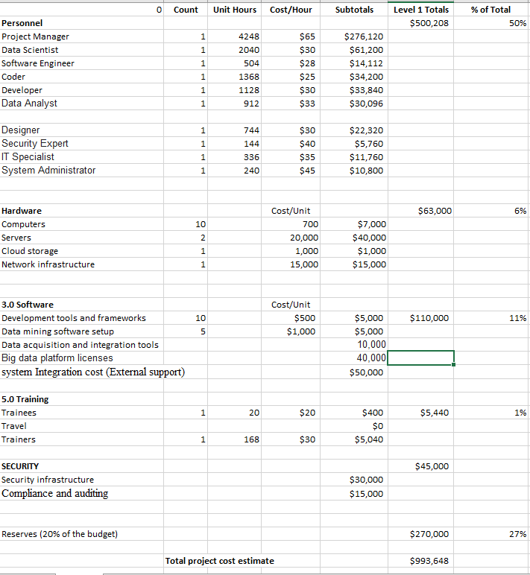

3.5.5. Stakeholders’ matrix

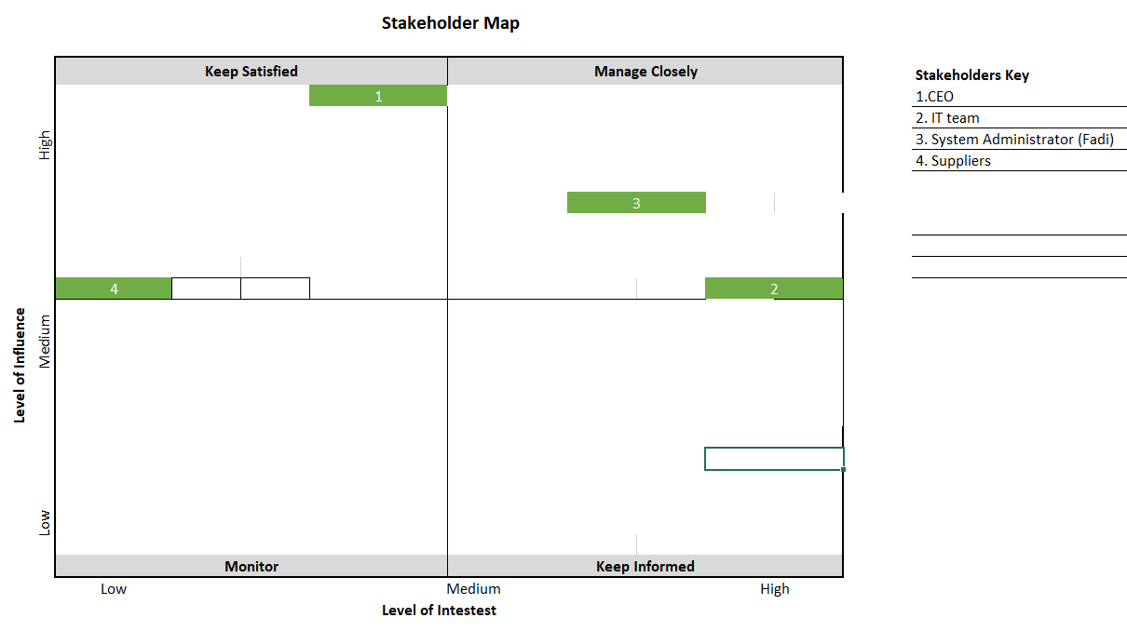

# 3.5.6 : Risk management plan Objective

**RISK TYPE:**

|  |  |  |  |
| --- | --- | --- | --- |
| **Scenario** | **Risk ID** | **Risk to project (L/M/H)** | **Mitigation Plan** |
| Hardware or software failure | **1** | **M** | Avoidance |
| bugs or errors in the system leading to data security breaches. | **2** | **H** | transference |
| natural disaster or power loss, I'm disrupting the progress of the project leading to losing data or system downtime | **3** | **M** | Avoidance |
| week communication between different stakeholders leading to misunderstanding. | **4** | **L** | Mitigation |
| Another company develop a similar solution | **5** | **L** | Acceptance |
| Using a data mining model that fails to provide accurate results. | **6** | **H** | Mitigation/ transference |

**Probability and Impact Matrix:**

|  |  |  |  |  |
| --- | --- | --- | --- | --- |
| **Inherent Risk** | | | | |
|  | | **Impact** | | |
| **Low** | **Medium** | **High** |
| **Probability** | **High** | 5 |  | 6 |
| **Medium** | 4 | 1 |  |
| **Low** |  | 3 | 2 |

3.5.9 Quality management plan:

QUALITY OBJECTIVES

|  |  |
| --- | --- |
| **Metric or Specification** | **Measure** |
| User engagement | monitor and analyze the amount of user interactions with a new big data system. Analytical tools could be used to assist the engagement metrics, for example how many active users, or the time spent on the platform, as well as the user feedback.  The goal is to achieve a user engagement rate over 80% |
| User adoption | Tracking the number of users that are using the new system. And monitor the curve for the adoption over time and identify any issues that make users avoid the adoption of this system. We could gather feedback from users in order to get an overall understanding of their experience and address any issues.  The goal is to have an adoption rate about 87% in the first four months |
| Technical issues/defects | implement strong protocols for testing for each phase in the development of the project in order to identify technical issues and resolve them.  Tracking the frequency and the seriousness of the reported errors.  The goal is to maintain an error rate below 3%. |
| Quality of features delivered/released | having good quality for the features in the system doing the development phase. As well as conducting regular testing and validation before we release any new feature. We could use the customer feedback and add test user acceptance to assess the future quality.  The goal is to have features exceeding 95% of the standard quality |
|  |  |

QUALITY ROLES AND RESPONSIBILITIES

|  |  |
| --- | --- |
| **Quality Roles** | **Responsibilities** |
| Developer Rami | perform regular testing for the software components, including system testing, and integration testing.  Identify and document any errors and ensure fast fixing. |
| Data analyst | Collecting and analyzing the user’s feedback  report any issues that are related to the user experience as well as suggesting improvements on the system. |
| Stakeholders(employees who would use the system) | daily engagement with the project as well as providing feedback on all the features in the system.  Daily participation user testing to gain an idea of user acceptance. |